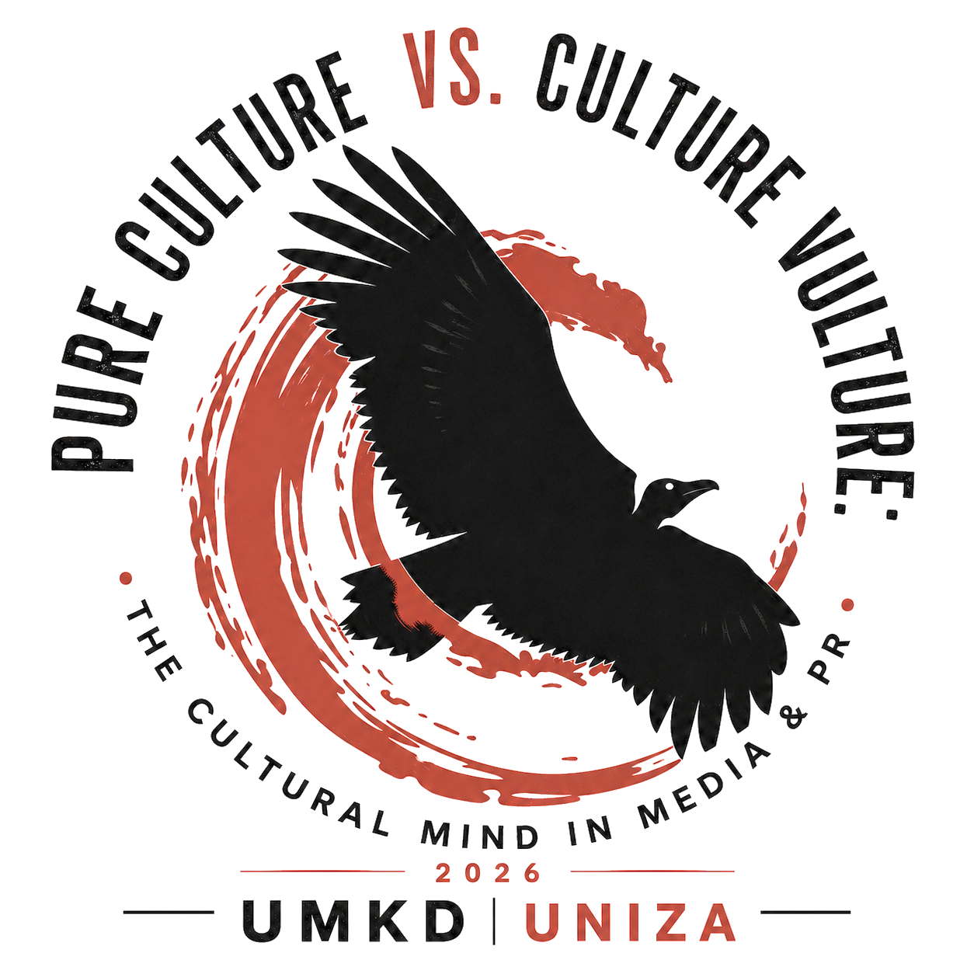
International Scientific Conference
TITLE OF THE CONFERENCE PAPER
(style used: CultureMind_name)
Author's name and surname
(Name and surname / font Times New Roman 16, bold)
University, Faculty
(Name of the author's workplace / font Times New Roman 14, bold)

Abstract
The the abstract contains information about the goals of the paper and briefly characterizes the content of the document, the focus of the contribution, and its scientific value.
Keywords: 3 to 5 keywords (written in English language). Words separated by a dot.
Font Times New Roman 12, line spacing 1
Information on creating a scientific article
The maximum length of the paper is 21600 characters, including references.
The structure of the paper must correspond to its scientific focus and content. The paper must include an abstract, keywords, an introduction, thematically structured main sections, a conclusion, a list of bibliographic references, an author profile, and information on project support (if applicable).
For empirical or research-oriented papers, authors may consider the IMRaD structure (Introduction, Methods, Results, and Discussion), which provides a clear layout of the paper according to the individual stages of scientific research.

INTRODUCTION
In the introduction, the author briefly and concisely characterizes the state of knowledge of the issue or practice in the field that is the subject of the paper and introduces the reader to the significance, aims and objectives of the paper.
- CHAPTER
Style used: CultureMind_chapter
Text in chapters and the whole document => Style used: CultureMind_text
  - Subchapter
Style used: CultureMind_subchapter
    - Level 3 Subchapter
Style used: CultureMind_subchapter_3

Instructions for illustrations:
Illustrations are pictures containing graphs, diagrams, maps, charts, etc. There is no need to distinguish between different types of illustrations, it is sufficient if they are all labelled as "Fig.".
The caption is given under the selected object - Times New Roman, size 9, bold font, black colour. Insert the caption by right-clicking the mouse and selecting "Insert caption..." from the menu. Align images and graphs to the centre.
Image caption, graph => Style applied: CultureMind_description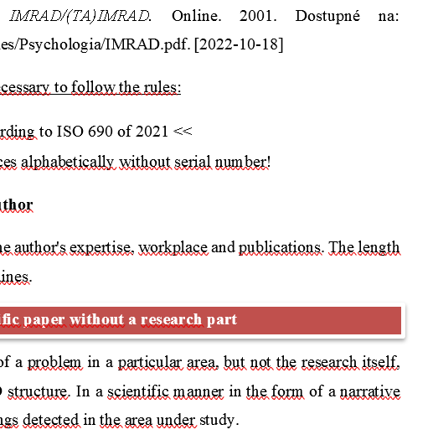
Fig. 1 Example

Instructions for tables:
We refer to the tables by the uniform term "Tab.". The label is placed above the selected object - Times New Roman, size 9, bold font, black colour. Insert the label by right-clicking the mouse and selecting "Insert description..." from the menu. We align the tables to the centre.
Table caption => Style applied: CultureMind_description
Table 1 Name

Resume
Includes a brief table of contents of the article, a summary overview. 5-11 lines.
Font used: Times New Roman 12 font, 1.5 line spacing.

Literature used
MACZKÓ, Ladislav, [2001]. IMRAD/(TA)IMRAD. Online. 2001. Dostupné na: https://www.vssvalzbety.sk/userfiles/Psychologia/IMRAD.pdf. [2022-10-18]
In the list of literature used, it is necessary to follow the rules:
- - >> Citation rules according to ISO 690 of 2021 <<
- - Sort information sources alphabetically without serial number!
Biographical profile of the author
Contains brief information on the research focus and professional experience relevant to the topic of the paper. Please provide the author profile in the third person. The length of the biographical profile is 5-11 lines.

