WRITE YOUR CONTRIBUTION IN THE FOLLOWING TEMPLATE IN THE PRESET A5 SIZE IN THE RANGE OF 6 – 10 PAGES
KNOWLEDGE ON THE MOVE: TRANSFORMATIONS IN THE SOCIAL SCIENCES (Times New Roman 12, small caps)

Ján NOVÁK, SK – Jana NOVÁKOVÁ, SK (Times New Roman 10)
(Throughout the document, the line spacing is 1.15., font size Times New Roman 10)

ABSTRACT
The social sciences are constantly evolving in response to changing social, political and technological conditions. Transformations in the Social Sciences explores the dynamics of knowledge and its transformation in the context of contemporary challenges. Contributors analyze new methodological approaches, interdisciplinary overlaps, and transformations in theoretical frameworks that reflect the complexity of today's world.
Key words: movement, education, sociology, ethics of science, innovation (max. 5 words)

INTRODUCTION (Times New Roman 10)
The authors focus on the university education of future teachers (standard text throughout the document in Times New Roman 10)....

Transformations in the social sciences examine the dynamics of knowledge and its transformation in the context of contemporary challenges (Klieštiková, 2022, p. 55).

1 THEORETICAL BACKGROUND

2 GOALS

3 METHODS
3.1 .....
3.2 .....

4 RESULTS

4.1 OPINION POLL..... (subchapter)

Diagram 1: Teachers supporting students' creativity (Times New Roman 10)

Source: Lokšová, Lokša (2003) (Times New Roman 9, italics)

Figure 1: State folk and town school in Malacky (Times New Roman 10)
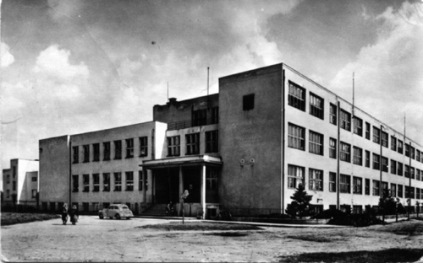
Source: Dulla, Moravčíková (2002) (Times New Roman 9, italics)

Table 1: Distribution of alternative schools (Times New Roman 10)
Alternative Schools
Non-state |  | State or Private
Classical (Reform) | Religious (Confessional) | Modern
Steiner | Catholic | with open teaching
Montessori | Protestant | Magnet Schools
Freint | Jewish | integrated schools
Petersen | and orthers | non-graded schools
Parkhurst |  | independent and others
Source: Průcha (1996) (Times New Roman 9, italics)

Graph 1: Illustration of the development of cooperative teaching implementation (Times New Roman 10)

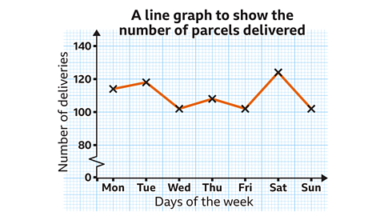
Source: own processing (Times New Roman 9, italics)
CONCLUSION
The issue of alternative education is an important and topical one in the context of current social and cultural developments. Changes in approaches to learning, with an emphasis on individualization, creativity, and student responsibility, point to the need for new pedagogical strategies that reflect the diversity of children's and young people's needs...

REFERENCES
KLIEŠTIKOVÁ, J. 2022. Alternative approaches in education and development of media literacy. Žilina: University of Žilina, p. 120. ISBN 978-80-554-0198-7.
SERPA, S., SANTOS, A., FERREIRA, C. 2020. Contributions of Ivan Illich to Education in a Digital Society. In Academic Journal of Interdisciplinary Studies, Vol. 9, No. 23. https://doi.org/10.36941/ajis-2020-0019.
TUREK, I. 2008. Didactics. Bratislava: WoltersKluwer, p. 620. ISBN 9788081680045.
ZELINA, M. 1996. Strategies and methods for the development of the child's personality : (methods of upbringing). Bratislava: Iris, p. 230. ISBN 8096701347.
According to ISO 690
Affiliation:
This contribution is a partial output of grant task VEGA No. 1/0550/24 ... (write the name after the dots).

CONTACT:
PaedDr. Ján NOVÁK, PhD.
Catholic University in Ružomberok, Faculty of Education
Department of Special Education
Hrabovská cesta 1, 034 01 Ružomberok
jan.novak@ku.sk

PaedDr. Jana NOVÁKOVÁ, PhD.
University of Žilina
Institute of Mediamatics and Cultural Heritage
Univerzitná 8215/1, 010 26 Žilina
jana.novakova@uniza.sk

