Title of the article
Subtitle
First name LAST NAME, First name LAST NAME
Abstract
The abstract should contain a brief description of the content and main results of the manuscript (max. 15 lines).
Keywords
List 3 - 5 keywords that are included in your article.

Introduction
Introduction to the issue itself - general introduction, current status, terminology used in relation to the phenomenon under study, definition of the specific area under study, which will be covered by the presented research.
Methodology
Determination of basic attributes:
- Research topic
- Research problem
- Research questions
- Research goals
It is further necessary to define:
- research subject and research population,
- research methods used.
Analysis and interpretation of research
Presentation of achieved results - analysis, comparison.
Discussion
A deeper analysis of the data collected. Answering the research questions and evaluating whether the research objectives have been met. To place the results obtained in context. Provide the researcher's perspective on the findings and discuss future intentions.
Limits of research
Research limitations that may be the subject of further research.
Conclusion
Summary of research results and findings.
List of sources used
>> ISO 690 citation rules <<
Author(s)
Each author of the article fills in basic contact details.
EXAMPLE:
Mgr. Peter Mrkvička, PhD.
peter.mrkvicka@umkd.uniza.sk
Institute of Mediamatics and Cultural Heritage
University of Žilina
Univerzitná 8215/1
010 26 Žilina
SLOVAK REPUBLIC
Brief professional orientation of the author(s) of 3-6 lines, including information about achievements, exhibitions, art cycles and publications.

EXAMPLE:
He graduated in library and information studies at the Faculty of Humanities of UNIZA, specializing in the media field and the work of an information specialist. In 2022, he received his PhD in Media and Communication Studies and works as an assistant professor at the same faculty. He teaches courses focused on media and marketing. He is a member of the media and marketing team #POSTUJEME and editor-in-chief of the student magazine KONTAKT. He has worked in various media outlets and is certified to teach homophobia and transphobia prevention. He founded the internet radio CezaR and worked on a grant project about the creative environment of Žilina.
Examples of scientific articles in MKD revue:
- Grafická výzdoba a typografia starých tlačí z bibliometrickej perspektívy
- Reflexia súčasného juhokórejského hudobného priemyslu: Prípadová štúdia piesne Daechwita
Formatting text in an article
- Subtitle: use the style called MKD_Podnadpis
- Text: use the style called MKD_Normalny
- Caption for images, graphs and tables: use the style called MKD_Popisok
We accept submissions in editable format. Pdfs are not accepted!
We accept submissions in Slovak, Czech and English. The authors themselves are responsible for the linguistic culture and content of their contributions.
If the paper is published in another journal, please notify the editors of mkd. Submissions should be sent electronically to the following email address mkdrevue@umkd.uniza.sk. The editorial board decides on the acceptance and publication of the article.
Labelling images and graphs
We refer to images and graphs by the single term „Figure“. The caption is placed under the selected object – Times New Roman, font size 9, bold font, black colour. Insert the label by right-clicking the mouse and select from the menu „Insert description“. Align images and graphs to the center.
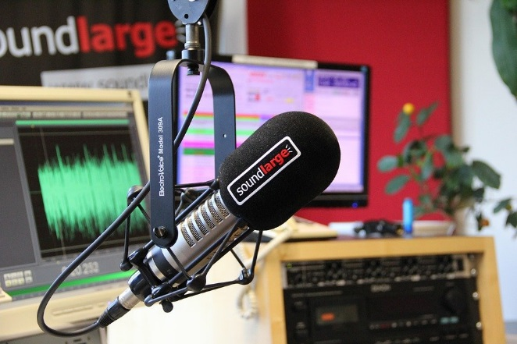
Figure 1 Studio in the radio

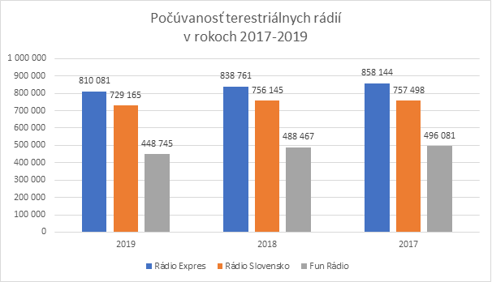
Figure 2 Terrestrial radio listenership
Marking of tables
We refer to the tables by the uniform term „Table“. The caption is placed under the selected object – Times New Roman, font size 9, bold font, black colour. Insert the label by right-clicking the mouse and select from the menu „Insert description“. We align the tables to the center.
Table 1 Comparison of DAB and internet radio (Somr 2013)
